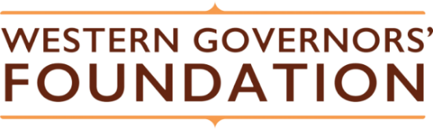

Celebrate the West Judging and Evaluation Standards and Criteria

Introduction
Celebrate the West is a high school visual arts competition hosted by the Western Governors’ Foundation (WGF). It is open to students in the western states and 3 U.S. territories whose Governors participate in the bipartisan Western Governors’ Association (WGA). Entrants will create an original two-dimensional artwork inspired by their state or otherwise evocative of the West.
Purpose
This document identifies the evaluation standards and criteria for the artworks submitted to Celebrate the West.
The 2022 judging panel consists of:
- Jason Situ
- Mark Salinas
- Pamela Kelly
- Ron Canos
- Sharon Rouse
Judging criteria:
Criteria | Description
Originality | Did the artist produce artwork that breaks or challenges convention?  Did the artist challenge the notion of how particular concepts, ideas themes, and emotions can be expressed?
Creativity and Imagination | Is the artwork unique in terms of themes and artistic expression?  Did the artist create something unique, powerful, and innovative?
Technical Skill | Did the artist use technique skillfully and effectively to advance an original perspective and/or personal vision?  Did the artist effectively use the medium in a meaningful way that draws the viewer into a sense of awe.
Expression of the Western theme | Did the artist successfully capture the western theme in an authentic and appropriate manner?
Emergence of Voice and/or Vison | Did the artist successfully present personal voice and/or vision?  Did the artist work with an authentic and unique point of view and style?  Does the artist successfully exhibit meaning, intentionality, and purpose in their artwork?

